Community Layer Update  
Technical Guide

2-3-2015

Document Reference:Version 1.4

**Version History**

|  |  |  |  |
| --- | --- | --- | --- |
| **ID** | **Changes** | **Date Created** | **Author** |
| 1.0 | Initial Version 1.0 | 08-27-2013 | STARR |
| 1.1 | Revised Version 1.1 | 11-06-2013 | STARR |
| 1.2 | Revised Version 1.2 | 11-22-2013 | STARR |
| 1.3 | Revised Version 1.3 | 12-10-2013 | STARR |
| 1.4 | Revised Version 1.4 | 02-03-2015 | STARR |

# 

1 Introduction 4

1.1 Background 4

2 Stakeholders and Dependencies 5

2.1 Project Stakeholders 5

2.2 System Dependencies 5

3 Special Considerations and Requirements 5

3.1 Special Considerations 5

3.2 Community Layer Business Requirements 6

4 Source Data and Technical Approach 7

4.1 Data Layers and Sources 7

4.2 Technical Approach 9

4.2.1 Extracting and Formatting CIS Data 9

4.2.2 Jurisdictional Boundaries - Creating Incorporated Place Boundaries and Assigning CIDs 10

4.2.3 Jurisdictional Boundaries - Creating County Subdivision Boundaries and Assigning CIDs 11

4.2.4 Jurisdictional Boundaries - Creating County Boundaries (Unincorporated Areas) and Assigning CIDs 12

4.2.5 Special Land Use Authority Areas - Creating Boundaries and Assigning CIDs 13

4.2.6 Tribal Boundaries - Creating Boundaries and Assigning CIDs 14

4.2.7 Assigning 2010 Census Population to Jurisdictional and Tribal Boundaries 15

4.2.8 Assigning 2010 Census Population to Special Land Use Authority Areas 15

4.2.9 Clipping Spatial Boundaries to United States Coastline 16

4.2.10 Creating the Union Community Layer 17

4.2.11 Creating the Unassigned CID Table 18

5 Maintenance Approach and Recommendations 18

5.1 Maintaining the Community Layer Database 18

5.1.1 Overview Database Maintenance 18

5.1.2 Maintenance Requests 19

5.1.3 Annual Updates to Jurisdictional and Tribal Boundaries 19

5.1.4 Annual Updates to Special Land Use Authority Areas 19

5.1.5 Decennial Updates to Jurisdictional and Tribal Boundaries 19

5.1.6 Union Community Layer 20

5.1.7 Unassigned CID Table 20

Appendix A. Data Model 21

Appendix B. Data Dictionary 22

# Introduction

The purpose of the *Community Layer Update – Technical Guide* is to document the business requirements and technical approach used to update FEMA’s Community Layer. This document includes the project background, source data dependencies, technical approach, stakeholders, and business requirements for the development of this data resource.

## Background

The Community Layer is a polygon GIS layer representing jurisdictional boundaries, population, and associated Community Identification Numbers (CIDs). Prior to this update, original data sources used for an earlier version of this layer included 2000 Census boundaries, political areas extracted from existing FIRM databases, and other additional ad-hoc information and manual processes. Fundamental to this layer is the CID information and its use for geospatially referencing community areas and their respective position within the National Flood Insurance Program (NFIP). As a result, this layer has since served as a common resource for multiple FEMA processes and systems including the Project Planning and Purchase Portal (P4), the Mitigation Action Tracker (MAT), the Mapping Information Platform (MIP), and the pending Mitigation Planning Portal (MPP).

Over time the current Community Layer became outdated as a result of several factors including:

* 2010 Census data and respective jurisdictional boundaries became available in the summer of 2011, where previous layer was based upon the 2000 census data as the primary boundary data source.
* Previously assigned ‘placeholder’ CIDs were designated for non-jurisdictional places (e.g. cemeteries, parks, etc.).
* Previously assigned ‘placeholder’ CIDs have since been removed from the Community Information System (CIS), the authoritative data source for CIDs.
* The community layer previously did not accommodate Tribal Areas.

As a result of these and other limitations, FEMA elected to update the Community Layer during the fall of 2013.

# Stakeholders and Dependencies

## Project Stakeholders

The following individuals directly contributed to the design, feedback and coordination of implementation:

* FEMA Project Point of Contact: Scott McAfee
* FEMA Program Area B Lead
* PTS Program Area B Leads and Support Staff
* PM Program Area B Leads and/or Support Staff
* CDS Program Area B Leads and/or Support Staff

## System Dependencies

The following systems are expected to leverage results of this Community Layer update:

* Project Planning and Purchase Portal (P4)
* Mitigation Action Tracker (MAT)
* Mitigation Planning Portal (MPP)
* Mapping Information Platform (MIP)

# Special Considerations and Requirements

## Special Considerations

The Community Information System (CIS) is FEMA’s authoritative data source for maintaining Community Identification (CID). CIDs are only assigned to governmental and non-governmental entities that possess land use authority necessary to manage NFIP regulations for a given area. That is not to say that all areas possessing a CID are active participants within the NFIP. In addition, not all areas possessing this authority have been issued a CID.

CIDs are typically assigned to entities that have been mapped by the NFIP or have individually requested to join the NFIP. These entities primarily exist as:

1. Jurisdictional Boundaries: where each jurisdiction is recognized by possessing political authority to enforce NFIP regulations.
2. Tribal Boundaries: where each tribal area is recognized as a state possessing the authority to enforce NFIP regulations.
3. Special Land Use Authority Areas: where each Special Land Use Authority is recognized as having been granted or delegated the authority to enforce NFIP regulations.

It should be noted that entities possessing CIDs can and do overlap in some areas of coverage. It should also be noted that some land areas can and do exist as a gap without CID coverage. Therefore, developing datasets that only included areas with assigned CIDs would not yield complete national coverage; thus preventing the Community Layer update from meeting full requirements and achieving its intended functions. As a result, any additional political jurisdictions lacking CIDs were included within the Jurisdictional Boundaries dataset (as referenced above) to achieve the desired national coverage.

Collectively, the above datasets were developed and delivered individually given the unique definition associated with each entity, its source information, and potential for overlap. Consolidating these datasets achieves a desired result of a single national layer with complete coverage of the United States, its territories, and total population. Other requirements of the Community Layer are further described below.

## Community Layer Business Requirements

Table 3.2.1 identifies business requirements for the updated Community Layer. These requirements were developed over the summer and fall of 2013, and were the result of a series of conference calls that included various FEMA stakeholders. Priorities were assigned based upon each item’s critical nature to supporting the overall project’s objectives.

**Table 3.2.1 Community Layer Business Requirements**

|  |  |  |
| --- | --- | --- |
| **ID** | **Business Requirement Statement** | **Priority** |
| 1 | Layer should provide national coverage and account for entire 2010 Census population | High |
| 2 | Layer should represent areas of legal authority corresponding to communities with assigned CIDs as reflected in CIS. See Special Districts note below*. | High |
| 3 | CIDs that cannot be assigned to land area shall be documented accordingly | High |
| 4 | Layer should accurately represent 2010 Census population data. | High |
| 5 | Layer should be topologically correct – no overlaps, no gaps. | High |
| 6 | Layer should include CSDGM 2.0 compliant metadata. | High |
| 7 | Layer should be compatible with Project Planning and Purchase Portal (P4). | High |
| 8 | Layer should be compatible with Mitigation Action Tracker (MAT). | High |
| 9 | Layer should be compatible with Mapping Information Platform (MIP). | High |
| 10 | Layer should be compatible with the pending Mitigation Planning Portal (MPP). | High |
| 11 | Layer should be updatable upon release of subsequent Census data (or process documented well so data can be recreated). | Med |
| 12 | Layer should be easily updated to reflect current NFIP status. | Med |
| 13 | Layer should be able to be updated if a new CID is created for a community. | Med |
| 14 | Layer should contain Census GEOID field for integration with other applications. | Med |

* Note that Special Districts are political subdivisions of a state established area to provide a single public service within a specific geographic area (e.g. water supply, sanitation, fire protection, education, etc.). They generally lack flood hazard management land use authorities and are administratively and fiscally independent from local governments. While, Special Districts may apply for grants for certain FEMA programs, they were omitted from the scope of this project.

# Source Data and Technical Approach

## Data Layers and Sources

Jurisdictional Boundaries 2010

* Description: Areas with local political land use authority to enforce NFIP regulations.
* Objectives: National coverage including territories and assigned populations.
* Boundary Sources:
  + 2010 US Census County
  + 2010 US Census County Subdivision
  + 2010 US Census Place
  + 2010 US Census State
  + 2010 US Census Block Groups Clipped to Coastline
* Population Sources:
  + 2010 US Census Blocks
* CID Sources:
  + October 2013 Custom CIS Report including
    - CID number
    - Community Name
    - County
    - State
    - Community Status
    - Tribal
* Special Notes:
  + Boundaries with CIDs and non-CIDs included

Special Land Use Authority Boundaries 2010

* Description: Areas with land use authority (granted or delegated) to enforce NFIP regulations.
* Objectives: Best available coverage with assigned weighted populations.
* Boundary Sources:
  + TCEQ_WATER_DISTRICTS.mdb <http://www.tceq.state.tx.us/gis/boundary.html>
  + SRIA.shp Eric Johnson, GIS Technician; 850-595-3463
  + CPA_boundary.shp John Constantinide, Alpha MRC Architects/Engineers; 321-449-9455
  + bnd13.shp Jia Wei, GIS Admin; 407-828-3838
  + jekyll_boundary_mhw.shp Jan Coyne, University of Georgia; 706-542-6193
  + metwp24p.shp <http://www.maine.gov/megis/catalog/>
  + District_Boundary.shp Dominador.elefante@njmeadowlands.gov; 201-460-4669
  + MHL_adm0 <http://www.gadm.org>
  + PLW_adm1 <http://www.gadm.org>
  + FSM_adm1 <http://www.gadm.org>
  + ne_10m_admin_0_countries <http://www.naturalearthdata.com/features>
  + Communities_Counties_As_of_July_2009 (used only for assigning CID locations that could not be identified from any other sources)
  + 2010 US Census Block Groups Clipped to Coastline
* Population Sources:
  + 2010 US Census Blocks (requires area weighting)
* CID Sources:
  + October 2013 Custom CIS Report including
    - CID number
    - Community Name
    - County
    - State
    - Community Status
    - Tribal
* Special Notes:
  + Only boundaries with CIDs were included
  + Boundaries obtained from the TCEQ WATER DISTRICTS included overlapping polygons.

Tribal Boundaries 2010

* Description: Areas with tribal land use authority to enforce NFIP regulations.
* Objectives: Best available coverage with assigned populations.
* Boundary Sources:
  + 2010 US Census AIANNH
  + 2010 US Census Block Groups Clipped to Coastline
* Population Sources:
  + 2010 US Census Blocks
* CID Sources:
  + October 2013 Custom CIS Report including
    - CID number
    - Community Name
    - County
    - State
    - Community Status
    - Tribal Status
* Special Notes:
  + Boundaries with CIDs and non-CIDs included

Union Community Layer

* Description: Jurisdictional, special land use, and tribal areas consolidated or ‘flattened’ with associated populations, CID designations, and other reference codes.
* Objectives: National coverage including territories and assigned populations.
* Boundary Sources:
  + Jurisdictional Boundaries 2010 layer (as described above)
  + Special Land Use Authority Areas 2010 layer (as described above)
  + Tribal Boundaries 2010 layer (as described above)
* Population Sources:
  + 2010 US Census Blocks (requires area weighting)
* CID Sources:
  + October 2013 CIS Community Status Book
* Special Notes:
  + Boundaries with CIDs and non-CIDs included

Unassigned CID Table

* Description: Identification of CIDs that could not be associated with a spatial boundary.
* Objectives: Documentation of potential gaps or issues associated with available geographies and/or CIS data. Good faith efforts were made to limit the number of unassigned CIDs.

## Technical Approach

### Extracting and Formatting CIS Data

A key component of the community layer is the ability to link CIS information spatially. Data from CIS cannot directly be joined with Census data. The two datasets have community name discrepancies which impede an exact match. Therefore, CIS data needs to be formatted to match Census community names. A custom report can be obtained from CIS to include a CID number, Community Name, County, State, Community Status, and Tribal status for all CIS records. Make sure all CID numbers are six digits and you follow the CIS community naming convention outlined in Table 4.2.1.1 below. Converting the CIS name “ADDISON, VILLAGE OF” to “ADDISON TOWN” involves removing unneeded spaces, comma, and preposition to make the join successful to the Census data. Using a comprehensive report at a national level gains efficiencies as bulk edits can be made. Data for each state should be extracted as needed by separating the CIS data into each type of community corresponding to the Census geography layers used, and a new JoinID column (e.g. ADDISON TOWN) can be created for each dataset allowing the CIS data to be joined to the Census data.

**Table 4.2.1.1 Join Requirements**

|  |  |  |  |  |
| --- | --- | --- | --- | --- |
| **Community Type** | **CIS Types** | **JoinID Created From** | **Example** | **Comments** |
| Incorporated Place | City, Municipality, Town, Village | Incorporated Place name + type | ADDISON TOWN | Represents the town of Addison |
| County Subdivision | Township, Charter Township, Borough | Subdivision name + County name | LAWRENCE TOWNSHIP CUMBERLAND | Represents Lawrence Township in Cumberland County; county name required since many duplicate township names in each state |
| County | County, Parish | County name | BUTLER COUNTY | Asterisks removed after name |

### Jurisdictional Boundaries - Creating Incorporated Place Boundaries and Assigning CIDs

The creation of the Jurisdictional Boundaries layer should occur on a state-by-state basis, so that individual differences associated with each state’s legal boundaries can be addressed more easily. For each state, the first step involves selecting and exporting all Incorporated Places from the Census Places data layer, so that only legal areas such as cities, towns, and villages are included. Within this incorporated places layer, the existing NAMELSAD10 field contains the geographic area’s name and the legal description/type, for example “Addison town” for the Town of Addison. Add a new JoinID field to the layer to convert the NAMELSAD10 field to uppercase characters. This JoinID field will then match the format of the extracted CIS data and allow for the best possible join results, since discrepancies in capitalization would otherwise prevent records from joining. Add new blank fields for CID, CIS_NAME, and CIS_COMMENTS to store CIS attributes.

Now join the CIS data to the incorporated places layer using the JoinID fields. The added CIS fields can be bulk calculated for all matching records. For each state, if any incorporated places with duplicate names exist within the CIS data, the CIS fields must be manually calculated. For example, in the state of Ohio, there are two entries for “OAKWOOD VILLAGE”, one is located in Paulding County, and one is located in Cuyahoga County. Since the Census Place data can cross county boundaries and the county(ies) are not stored as attributes, the Census Place layer will need to be loaded into a GIS map along with the county boundaries to visually determine the county each “OAKWOOD VILLAGE” polygon is located within. The correct CIS data should be manually calculated for these polygons.

Any unmatched records in the CIS data should be manually checked to determine if there are discrepancies in spelling or formatting between the Census data and the CIS data (e.g. Sweetwater versus Sweet Water, or St. Florian versus Saint Florian). Add a temporary field to the CIS data containing the name as shown in the Census data; this allows the CIS data to be rejoined to the incorporated places layer when needed.

For some CIS records unable to be matched to the Census incorporated place data, the Census Designated Places (CDP) statistical geographical areas can be utilized (e.g., special areas such as air force bases or fire districts in Connecticut, or communities that became incorporated after the most recent Census Places layer was created). For CIS communities that exist within the CDPs, copy the polygon into the working incorporated places layer. Add new blank fields for CID, CIS_NAME, and CIS_COMMENTS to the dataset. Now, join the data and calculate the attributes for the new blank fields. All remaining unmatched CID records need to be reported in the Unassigned CID Table within the database.

For all polygons derived from the 2010 Census Places layer, the “SOURCE” field in the Jurisdictional Boundaries layer is populated with the code “P”.

### Jurisdictional Boundaries - Creating County Subdivision Boundaries and Assigning CIDs

For certain states such as Michigan, there are townships or other county subdivision areas of legal authority that have CIDs or may potentially be assigned CIDs in the future (i.e. at least one other similar county subdivision currently has a CID assigned to it in the state). Boundaries for these areas can be created by extracting the applicable Minor Civil Divisions from the Census County Subdivision dataset. To keep the Jurisdictional Boundaries layer topologically correct, delete the incorporated places within each county subdivision using the ArcGIS Erase function. The output of the function is depicted in Figure 4.2.3.1.

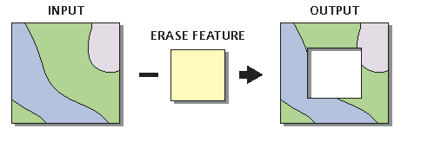

**Figure 4.2.3.1** ArcGIS Erase Function

Within the county subdivisions layer, the existing NAMELSAD10 field contains the geographic area’s name and the legal description/type, for example “Mason township”. This field alone cannot be used as an effective join field to the CIS data since the same township name is usually used within multiple counties. To determine the county name for the subdivisions the COUNTYFP10 field containing the county’s FIPS code can be joined to a FIPS lookup table and calculated the county name within each county subdivision. Then create a new JoinID field and add it to the county subdivision layer. Perform a calculation to concatenate the NAMELSAD10 field with the new county name field. Remember to convert the text string to uppercase characters so that the JoinID format matches what was already created from the CIS data.

Similar to the join procedure described above for incorporated places, the CIS county subdivision data can then be joined to the county subdivisions so that the added CIS fields can be calculated. Add new blank fields for CID, CIS_NAME, and CIS_COMMENTS to the dataset. Now, join the data and calculate the attributes. All unmatched CID records need to be reported in the Unassigned CID Table within the database.

For all polygons derived from the 2010 Census County Subdivisions layer, the “SOURCE” field in the Jurisdictional Boundaries layer is populated with the code “S”.

Note, in the states of Minnesota, North Carolina, and North Dakota, only those townships that currently have a CID assigned to them are incorporated into the Jurisdictional Boundaries layer. This is due to the fact that these states have townships that comprise the entire extent of the counties, and these states also have CID numbers assigned to each county. In order to maintain these county CID numbers and to maintain a topologically correct layer (no overlapping polygons) all townships could not be included in the Jurisdictional Boundaries layer.

### Jurisdictional Boundaries - Creating County Boundaries (Unincorporated Areas) and Assigning CIDs

After the creation of the incorporated places and county subdivisions is complete, the boundaries for the unincorporated parts of counties can be created. Using the Census Counties layer, the incorporated places and county subdivisions within each county can be deleted using the ArcGIS Analysis Tools\Overlay\Erase function. The output of the function is depicted in Figure 4.2.4.1. To start, create a new JoinID field to the layer to convert the NAMELSAD10 field to uppercase characters and add new blank fields for CID, CIS_NAME, and CIS_COMMENTS to the dataset.



**Figure 4.2.4.1** ArcGIS Erase Function

Similar to the join procedure described above for incorporated places, the CIS county data can be joined to the county boundaries so that the added CIS fields can be calculated. All unmatched CID records need to be reported in the Unassigned CID Table within the database.

For all polygons derived from the 2010 Census County layer, the “SOURCE” field in the Jurisdictional Boundaries layer is populated with the code “C”.

Note, for many states that contain townships or other county subdivisions that comprise the entire extent of the counties, the county boundaries are not included in the Jurisdictional Boundaries layer, in order to maintain a layer that is topologically correct (no overlapping polygons). The townships in these states are assigned CID numbers, while the counties do not have CID numbers. This includes the states of Connecticut, Maine, Michigan, New Hampshire, New Jersey, New York, Pennsylvania, Rhode Island, and Vermont.

### Special Land Use Authority Areas - Creating Boundaries and Assigning CIDs

The boundaries for the special land use authority areas are determined by looking at the unmatched records from the CIS data that did not join to the Census data. These unmatched records with an exception to Maine townships tend to contain the word “District” or something in similar fashion within the CIS community name field. Records should be researched in order to obtain a spatial boundary for incorporation into the special land use authority layer. Conduct an internet search for each area or set of areas if maintained by the same land use authority agency. If well-documented spatial data exists online directly from the special land use authority agency (not from a third party), the data should be downloaded along with any applicable metadata and documentation. If spatial data is not available online, contact the agency via phone or email to obtain spatial data. Finally, if no response is received from the agency, then spatial data from the Communities Counties As of July 2009 (previous community layer) shapefile can be utilized. CIDs can be manually assigned to each spatial area based upon the CIS name.

For certain areas in Texas the boundaries obtained from the TCEQ WATER DISTRICTS had overlapping polygons as shown in figure 4.2.5.1. These overlaps would have to be resolved to meet the Community Layer’s business requirements. The special land use authority boundaries were loaded into an ArcGIS topology feature class where “sliver” polygons were removed and bigger polygon overlaps were assessed individually and merged with an appropriate neighbor.

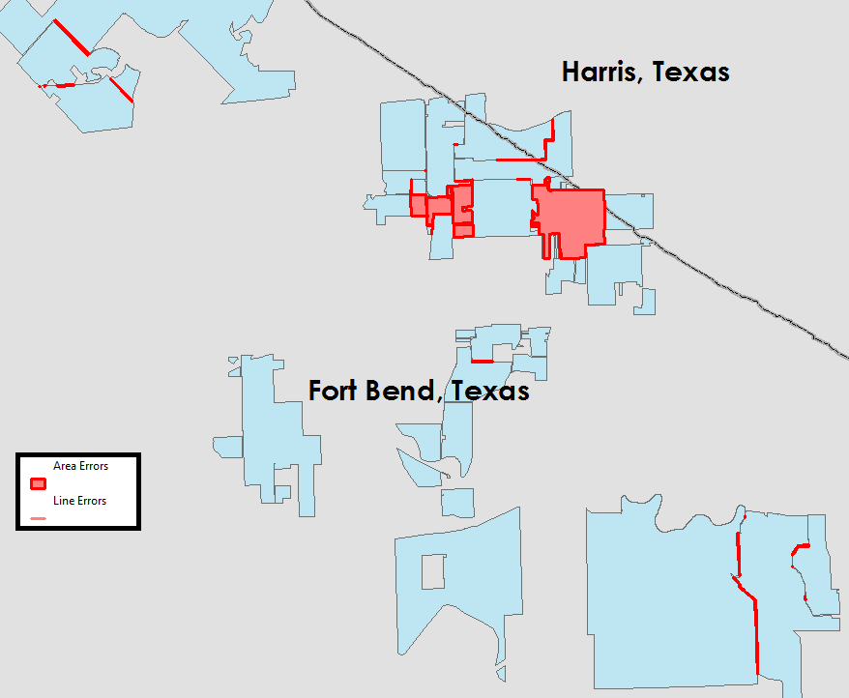

Figure 4.2.5.1 Overlapping Polygons

### Tribal Boundaries - Creating Boundaries and Assigning CIDs

To create the Tribal boundaries, all data from the 2010 Census American Indian, Alaska Native, and Native Hawaiian (AIANNH) areas were utilized for each state. To assign CIDs to each area, the NAME field in the AIANNH can be manually compared to the CIS database name. An automated procedure to join the names will not be effective since the names vary significantly.

For all polygons derived from the 2010 Census AIANNH layer, the “SOURCE” field in the Tribal Boundaries layer is populated with the code “A”.

### Assigning 2010 Census Population to Jurisdictional and Tribal Boundaries

For the Jurisdictional and Tribal Boundaries, the 2010 Census population can be calculated by joining the layers to the corresponding Census TIGER/Line layers with Demographic Profile 1 attributes, using the GEOID10 field. When joined, the population can be directly calculated into the spatial data.

However, the population for the county subdivisions and the unincorporated areas of the counties must be calculated using Census block data, since the boundaries do not directly match any Census tabulation areas. First, convert the Census block polygon layers containing population data to centroid points, making sure to select the option to force the point to be located within the polygon. Next perform a spatial join to sum the population of all points located within each unincorporated county. This summed value is the assigned population for the county. This spatial join operation versus an area-weighting technique can be utilized since all of the boundaries used to create the Community Layer are Census boundaries that completely contain Census blocks (blocks never cross boundaries of Census tabulation areas).

The three intermediate boundary layers for incorporated places, county subdivisions, and unincorporated portions of counties for all states can be merged to create a single Jurisdictional Boundaries layer that contains both CIS and population data. In both the Jurisdictional Boundaries and Tribal Boundaries layers, to maintain a unique identifier for each polygon, add a new field called “AREA_ID” and calculate as follows:

Jurisdictional Boundaries J_AREA_ID = 2-digit State FIPS code + “J” + XXXX

Tribal Boundaries T_AREA_ID = 2-digit State FIPS code + “T” for Trust Land or “R” for Reservation + XXXX. Determining the “T” or “R” usage can be derived from the “T_GEOID10” field using the suffix.

The XXXX denotes a unique numerical counter within each state (e.g. 0001, 0002, 0003, etc.).

### Assigning 2010 Census Population to Special Land Use Authority Areas

To assign population to the special land use authority areas, an area-weighting technique is required since the Census block boundaries do not align with the special land use authority areas. First, perform a spatial intersect operation on the special land use areas and the corresponding Census block polygons. The area of each new “split” polygon within the intersected layer can be calculated, and the population for each individual polygon can be determined using the following formula:

Population of Intersect Layer Polygon = Block Population * (Area of Polygon/Area of Block)

To calculate the total population within each special land use authority area (calculates the sum of the population for all polygons that fall within each special land use authority area) a summarize operation can be performed.

To maintain a unique identifier for each polygon add a new field called “S_AREA_ID” and calculate as follows:

Special Land Use Authority S_AREA_ID = 2-digit State FIPS code + “S” + XXXX

The XXXX denotes a unique numerical counter within each state (e.g. 0001, 0002, 0003, etc.).

The 2010 U.S. Census Block data does not have coverage for all areas within the community layer. For the areas of Palau, U.S. Minor Outlying Islands, Micronesia, and the Marshal Islands no population can be assigned.

### Clipping Spatial Boundaries to United States Coastline

This section explains the process to create community layers that more closely resemble the U.S. coastline. This would be for aesthetic reasons only and does not alter any pertinent data previously created in the sections above. The Census data includes open water areas which can be removed to create a better coastal representation. The steps below document an approach to create a dataset that can be used as a clipping source against the community spatial layers.

1. For a desired area take Census block data and calculate values for a new field called “Tract”. This can be done using the first eleven digits from the BLOCKID10 field (e.g. 25025980101).
2. Use the ArcGIS Data Management Tools\Generalization\Dissolve function, perform a dissolve on the “Tract” field and make sure that you SUM the HOUSING10 and POP10 fields. This function creates a new spatial file (clip feature). The output of the function is depicted in Figure 4.2.9.1.

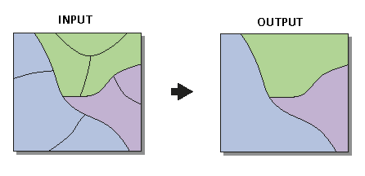

**Figure 4.2.9.1.** ArcGIS Dissolve Function

1. Take the new spatial file created in Step 2 and set a definition query of "SUM_HOUSING10" <> 0 OR "SUM_POP10" <> 0 and make sure you don’t have any interior polygon(s) missing (e.g. wildlife refuge area). If so, you need to add the area(s) back in.
2. Using the ArcGIS Analysis Tools\Extract\Clip function, perform a clip on the desired community layer boundary (input feature) to the layer created in Step 3 as your clip feature. Make sure the clip feature maintains the definition query set in Step 3. The output of the function is depicted in Figure 4.2.9.1.

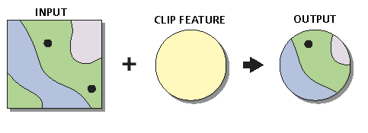

**Figure 4.2.9.2.** ArcGIS Clip Function

1. Once the clip function has been performed it creates another spatial file that has the coastline clipped

### Creating the Union Community Layer

The Union Community Layer is a comprehensive spatial layer combining attributes and geometry from the Jurisdictional, Special Land Use Authority, and Tribal boundaries. This merged layer is created using the ArcGIS Analysis Tools\Overlay\Union function. The output of the function is depicted in Figure 4.2.10.1. All attributes from the three layers should be carried over into their respective fields except for population.

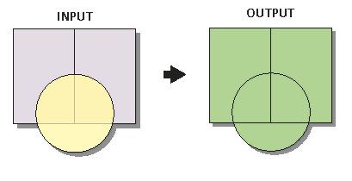

**Figure 4.2.10.1.** ArcGIS Union Function

To maintain a unique identifier for each polygon add a new field called “U_AREA_ID” and calculate as follows:

Union Community Layer U_AREA_ID = 2-digit State FIPS code + “U” + XXXXX

The XXXXX denotes a unique numerical counter within each state (e.g. 00001, 00002, 00003, etc.).

### Creating the Unassigned CID Table

This table is created from all the CIS unmatched CID records where a spatial footprint could not be obtained from an authoritative source or joined to Census data.

# Maintenance Approach and Recommendations

## Maintaining the Community Layer Database

The Community Layer database is pertinent to many FEMA reporting systems when it comes to identifying community boundaries, population, and CID information. It is important that a process be in place for updating the community layer database regarding these attributes. Because some data will remain static, a complete database overhaul is not necessary from year to year. For example, the Jurisdictional and Tribal boundaries as well as population data are derived from Census compiled every ten years. However, as communities are added to CIS, it will be important that these changes are reflected in the database. This would be best assessed from year to year which could include:

* Assigning a CID to an existing boundary in the Jurisdictional or Tribal boundaries
* Adding a new record to the Special Land Use Authority Area

The updates to the Community Layer are important to preserve validity and keeping the database dynamic. A “Core Team” identified by FEMA will be the gate keeper and responsible for adhering to the data model standards and processes defined throughout this document.

### Overview Database Maintenance

* Annual Updates
  + Confirm/Update CIS Name
  + Add any new CID numbers to existing Jurisdictional or Tribal Boundaries
  + Update Special Land Use Authority Areas
    - Area weight population if needed
  + Update Unassigned CID Table
  + Update Community Union Layer
* Decennial Updates
  + Update Census Jurisdictional and Tribal Boundaries
  + Update population numbers
  + Assign CID numbers to updated Census Boundaries
  + Update Special Land Use Authority Areas
    - Area weight population if needed
  + Update Unassigned CID Table
  + Update Community Union Layer

### Maintenance Requests

Within the community layer database is a Maintenance Request feature class that can act as a reporting mechanism or temporary placeholder for any needed community layer updates. This layer should be utilized by stakeholders between Annual and Decennial update periods. The “Core Team” will assess the Maintenance Request layer whenever updates are made to the Jurisdictional, Special Land Use Authority, or Tribal boundary layers. The Maintenance Request layer shares many similarities between the other layers to aid in the update process.

### Annual Updates to Jurisdictional and Tribal Boundaries

On a yearly basis, CIS data should be joined to the existing spatial data. The process will require joining data on CID to identify the records that have been newly added during the previous year. The CIS data pull will be a custom report (spreadsheet) from CIS as discussed in section 4.1. Any CID records that do not join to one of the three core spatial layers (Jurisdictional, Tribal, and Special Land Use Authority), and is also not found in the “Unassigned CID Table” will be identified as “new CIDs” that will need to be investigated. If possible, the new CIDs will be assigned to an existing polygon within the Jurisdictional or Tribal Boundaries layers, or a new polygon will be obtained and added to the Special Land Use Authority Areas layer (see section 5.1.3 below). If the “Core Team” determines that a CID is unable to or does not need to be represented spatially, the CID will be added to the “Unassigned CID Table”. Revisions to polygon geometry or the 2010 population field will not be conducted on a yearly basis for the Jurisdictional Boundaries or Tribal Boundaries layers.

### Annual Updates to Special Land Use Authority Areas

The Special Land Use Authority Areas layer will need to be updated when CID records are added that are not represented in either the Census Jurisdictional or Tribal boundaries and meet the definition of a Special Land Use Authority Area in section 3.1. The boundaries of these areas are defined by each area’s authority/entity. The authority/entity may need to be contacted to obtain a boundary footprint if an accurate boundary cannot be found online. If no boundary can be obtained, then the CID should be added to the “Unassigned CID Table”. Also, if it is discovered that a Special Land Use Authority Area boundary has been revised, then the new boundary should be represented as well as transferring all previous attributes. If any new boundaries are added, or any existing boundaries are revised within the Special Land Use Authority Area layer, a new area-weighting procedure will be required to determine the population for each area (refer to section 4.2.8).

### Decennial Updates to Jurisdictional and Tribal Boundaries

The US Census Bureau releases updated TIGER/Line spatial data corresponding to the decennial Census results every ten years, which includes boundary, population, and name updates. Section 4.1 describes the exact data needed to be downloaded from Census.gov. These Census polygons will need to be formatted/processed to be topologically correct by following the procedures documented in sections 4.2.3, 4.2.4, 4.2.5, and 4.2.6. For areas in which duplicate polygons exist (e.g. county and city polygon are identical), care should be taken to preserve the polygon with the GEOID that is currently in the existing community layer. The updated Census population must then be calculated using the procedures in section 4.2.7. This data can then be imported into the community layer data model.

After the updated Census data is loaded into a “new” community layer database (data model), the Jurisdictional Boundaries and Tribal Boundaries layers will each be joined to the corresponding existing community layer using GEOID. This will allow the CID and Area_ID fields to be calculated such that these fields remain consistent between community layer updates. Using the CID field, the Jurisdictional Boundaries and Tribal Boundaries layer will then be joined to the current CIS data, so that the CIS name and comment fields can be updated. Unique Area_IDs will need to be calculated for any new polygons that were not in the previous community layer, such that no Area_IDs are utilized that were previously assigned to another community. Using the ArcGIS “Select by Location” function or selecting by State FIPS codes, the Region field should be calculated to identify the FEMA region in which each community is located. Lastly, the spatial boundaries will need to be clipped to United States coastline using the steps outlined in section 4.2.9.

### Union Community Layer

Follow instructions in section 4.2.10.

### Unassigned CID Table

Follow instructions in section 4.2.11.

# Appendix A. Data Model

**2010 Community Layer Data Model**

(Coordinate System: GCS_North_American_1983)

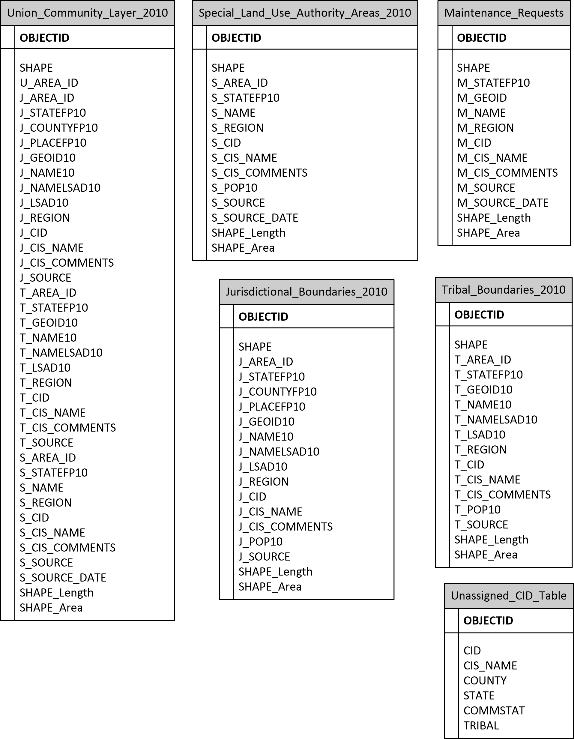

# Appendix B. Data Dictionary

**Jurisdictional_Boundaries_2010 Feature Class**

|  |  |  |
| --- | --- | --- |
| **Field** | **Description** | **Domain Table** |
| OBJECTID | Internal feature number |  |
| SHAPE | Feature geometry |  |
| J_AREA_ID | Unique ID created for each community in layer; J_AREA_ID = 2-digit State FIPS code + “J” + XXXX |  |
| J_STATEFP10 | Federal Information Processing Standards code for State name | dStateFIPS |
| J_COUNTYFP10 | Federal Information Processing Standards code for County name | dCountyFIPS |
| J_PLACEFP10 | Federal Information Processing Standards code for Place name |  |
| J_GEOID10 | 2010 Census nation-based code. Identification code for various geometries. Based on a concatenation of state FIPS codes and codes for the data used to populate this dataset |  |
| J_NAME10 | Entity name |  |
| J_NAMELSAD10 | Current name for the area that includes Legal/Statistical Area Definition |  |
| J_LSAD10 | Legal/Statistical Area Definition codes | dLSAD |
| J_REGION | FEMA Region Number |  |
| J_CID | Community Identification number from CIS database |  |
| J_CIS_NAME | Community Information System name |  |
| J_CIS_COMMENTS | General comment field used to track extraneous information |  |
| J_POP10 | 2010 population derived from US Census data |  |
| J_SOURCE | Denotes source of spatial data | dSource |
| SHAPE_Length | Length of feature in internal units |  |
| SHAPE_Area | Area of feature in internal units squared |  |

**Maintenance_Requests Feature Class**

|  |  |  |
| --- | --- | --- |
| **Field** | **Description** | **Domain Table** |
| OBJECTID | Internal feature number |  |
| SHAPE | Feature geometry |  |
| M_STATEFP10 | Federal Information Processing Standards code for State name | dStateFIPS |
| M_GEOID | Census identification code for various geometries. Based on a concatenation of state FIPS codes and codes for the data used to populate this dataset |  |
| M_NAME | Entity name |  |
| M_REGION | FEMA Region Number |  |
| M_CID | Community Identification number from CIS database |  |
| M_CIS_NAME | Community Information System name |  |
| M_CIS_COMMENTS | General comment field used to track extraneous information |  |
| M_SOURCE | Denotes source of spatial data |  |
| M_SOURCE_DATE | Date that the data was obtained |  |
| SHAPE_Length | Length of feature in internal units |  |
| SHAPE_Area | Area of feature in internal units squared |  |

**Special_Land_Use_Authority_Areas_2010 Feature Class**

|  |  |  |
| --- | --- | --- |
| **Field** | **Description** | **Domain Table** |
| OBJECTID | Internal feature number |  |
| SHAPE | Feature geometry |  |
| S_AREA_ID | Unique ID created for each community in layer; S_AREA_ID = 2-digit State FIPS code + “S” + XXXX |  |
| S_STATEFP10 | Federal Information Processing Standards code for State name | dStateFIPS |
| S_NAME | Entity name |  |
| S_REGION | FEMA Region Number |  |
| S_CID | Community Identification number from CIS database |  |
| S_CIS_NAME | Community Information System name |  |
| S_CIS_COMMENTS | General comment field used to track extraneous information |  |
| S_POP10 | 2010 population derived from US Census data |  |
| S_SOURCE | Denotes source of spatial data |  |
| S_SOURCE_DATE | Date that the data was obtained |  |
| SHAPE_Length | Length of feature in internal units |  |
| SHAPE_Area | Area of feature in internal units squared |  |

**Tribal_Boundaries_2010 Feature Class**

|  |  |  |
| --- | --- | --- |
| **Field** | **Description** | **Domain Table** |
| OBJECTID | Internal feature number |  |
| SHAPE | Feature geometry |  |
| T_AREA_ID | Unique ID created for each community in layer; T_AREA_ID = 2-digit State FIPS code + “T” for Trust Land or “R” for Reservation + XXXX. Determining the “T” or “R” usage can be derived from the “T_GEOID10” field using the suffix. |  |
| T_STATEFP10 | Federal Information Processing Standards code for State name | dStateFIPS |
| T_GEOID10 | 2010 Census nation-based code. Identification code for various geometries. Based on a concatenation of state FIPS codes and codes for the data used to populate this dataset |  |
| T_NAME10 | Entity name |  |
| T_NAMELSAD10 | Current name for the area that includes Legal/Statistical Area Definition |  |
| T_LSAD10 | Legal/Statistical Area Definition codes | dLSAD |
| T_REGION | FEMA Region Number |  |
| T_CID | Community Identification number from CIS database |  |
| T_CIS_NAME | Community Information System name |  |
| T_CIS_COMMENTS | General comment field used to track extraneous information |  |
| T_POP10 | 2010 population derived from US Census data |  |
| T_SOURCE | Denotes source of spatial data | dSource |
| SHAPE_Length | Length of feature in internal units |  |
| SHAPE_Area | Area of feature in internal units squared |  |

**Union_Community_Layer_2010 Feature Class**

|  |  |  |
| --- | --- | --- |
| **Field** | **Description** | **Domain Table** |
| OBJECTID | Internal feature number |  |
| SHAPE | Feature geometry |  |
| U_AREA_ID | Unique ID created for each community in layer; U_AREA_ID = 2-digit State FIPS code + “U” + XXXXX |  |
| J_AREA_ID | Unique ID created for each community in layer; J_AREA_ID = 2-digit State FIPS code + “J” + XXXX |  |
| J_STATEFP10 | Federal Information Processing Standards code for State name | dStateFIPS |
| J_COUNTYFP10 | Federal Information Processing Standards code for County name | dCountyFIPS |
| J_PLACEFP10 | Federal Information Processing Standards code for Place name |  |
| J_GEOID10 | 2010 Census nation-based code. Identification code for various geometries. Based on a concatenation of state FIPS codes and codes for the data used to populate this dataset |  |
| J_NAME10 | Entity name |  |
| J_NAMELSAD10 | Current name for the area that includes Legal/Statistical Area Definition |  |
| J_LSAD10 | Legal/Statistical Area Definition codes | dLSAD |
| J_REGION | FEMA Region Number |  |
| J_CID | Community Identification number from CIS database |  |
| J_CIS_NAME | Community Information System name |  |
| J_CIS_COMMENTS | General comment field used to track extraneous information |  |
| J_SOURCE | Denotes source of spatial data | dSource |
| T_AREA_ID | Unique ID created for each community in layer; T_AREA_ID = 2-digit State FIPS code + “T” for Trust Land or “R” for Reservation + XXXX. Determining the “T” or “R” usage can be derived from the “T_GEOID10” field using the suffix. |  |
| T_STATEFP10 | Federal Information Processing Standards code for State name | dStateFIPS |
| T_GEOID10 | 2010 Census nation-based code. Identification code for various geometries. Based on a concatenation of state FIPS codes and codes for the data used to populate this dataset |  |
| T_NAME10 | Entity name |  |
| T_NAMELSAD10 | Current name for the area that includes Legal/Statistical Area Definition |  |
| T_LSAD10 | Legal/Statistical Area Definition codes | dLSAD |
| T_REGION | FEMA Region Number |  |
| T_CID | Community Identification number from CIS database |  |
| T_CIS_NAME | Community Information System name |  |
| T_CIS_COMMENTS | General comment field used to track extraneous information |  |
| T_SOURCE | Denotes source of spatial data | dSource |
| S_AREA_ID | Unique ID created for each community in layer; S_AREA_ID = 2-digit State FIPS code + “S” + XXXX |  |
| S_STATEFP10 | Federal Information Processing Standards code for State name | dStateFIPS |
| S_NAME | Entity name |  |
| S_REGION | FEMA Region Number |  |
| S_CID | Community Identification number from CIS database |  |
| S_CIS_NAME | Community Information System name |  |
| S_CIS_COMMENTS | General comment field used to track extraneous information |  |
| S_SOURCE | Denotes source of spatial data |  |
| S_SOURCE_DATE | Date that the data was obtained |  |
| SHAPE_Length | Length of feature in internal units |  |
| SHAPE_Area | Area of feature in internal units squared |  |

**Unassigned_CID_Table**

|  |  |  |
| --- | --- | --- |
| **Field** | **Description** | **Domain Table** |
| CID | Community Identification number from CIS database |  |
| CIS_NAME | Community Information System name |  |
| COUNTY | County name |  |
| STATE | State name |  |
| COMMSTAT | National Flood Insurance Program participation status |  |
| TRIBAL | Is the community a Tribe (Yes/No) |  |